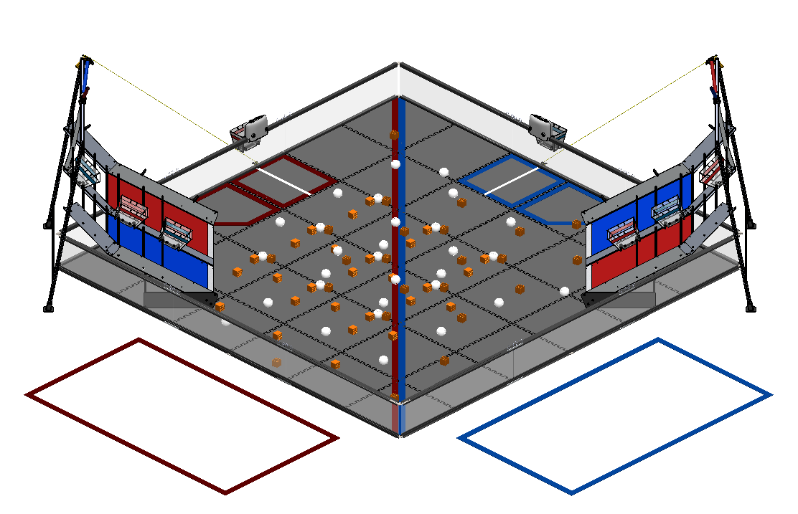
F.T.C. 2015-16

“Res-Q”

PHI Alpha Hardware Log

“Robot - X”

Our robot, given the name of “Robot – X”, is the one of the first tread driven robots that our team has ever built. In the past, we have chosen to design a robot with a wheel drive train, but this year, we decided that tread may be a more effective system for this year's challenge rather than our traditional wheel system. Our robot is built of primarily Tetrix metal parts, but we do have some custom made pieces. Has several functions. On the from of the robot, there is a rake and bucket assembly that is used for picking up balls and blocks to score in the mountain buckets. On the rear, we designed and built a powered wheelie bar, to keep the robot stable while climbing the mountian during the match, as well as during the end game. A servo is mounted on the front left corner of the robot, which is attached to a carbon fiber rod. This is a little device we call the whip, which is used in the end game to lift the robot

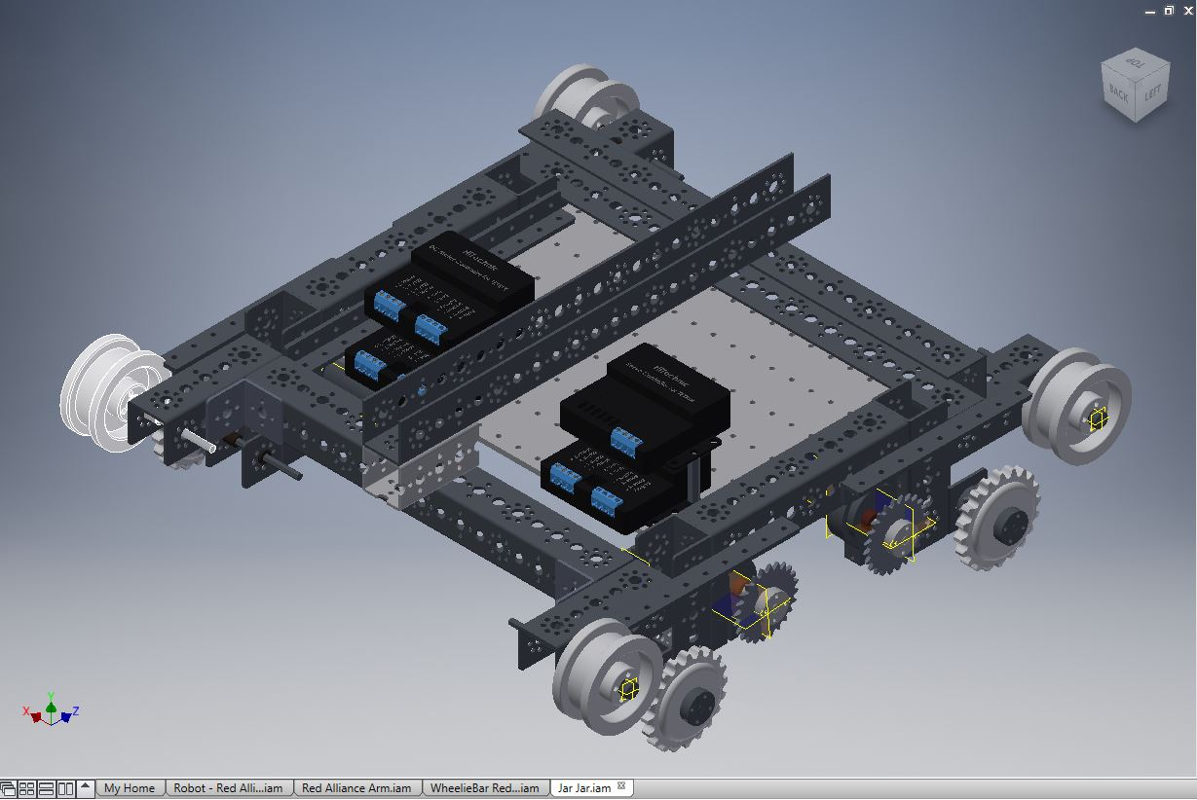
Drive System And Chassis

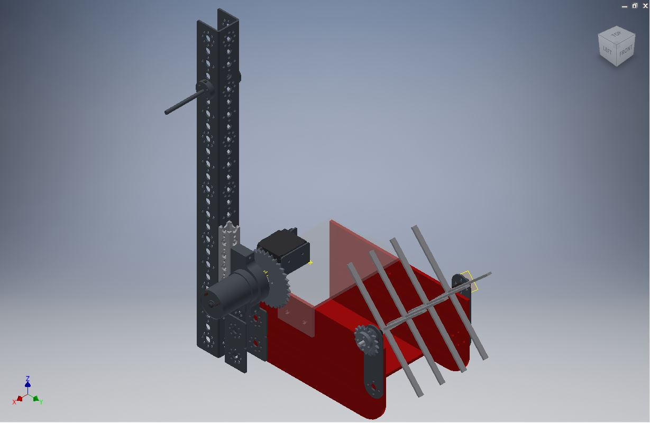
The Arm

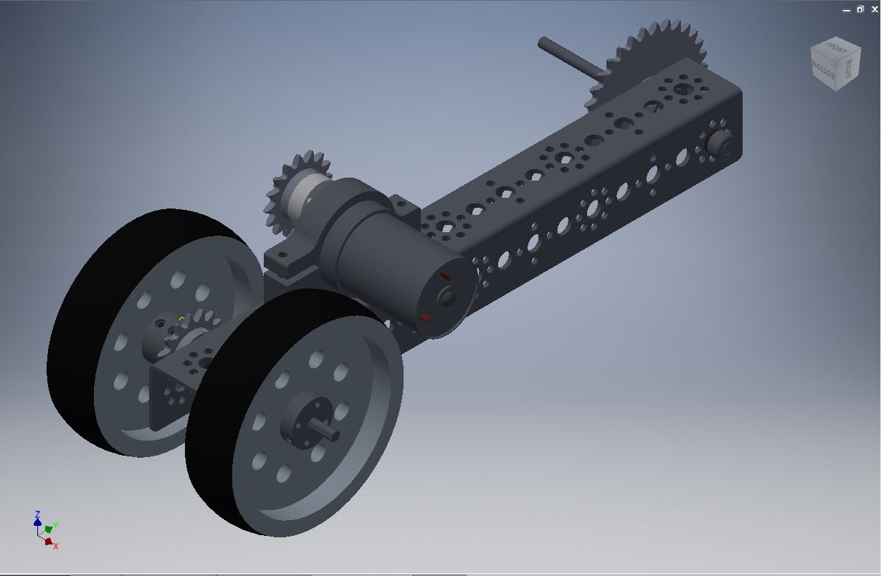
The Wheelie Bar

The Wicked Whip of the Left (The Whip)

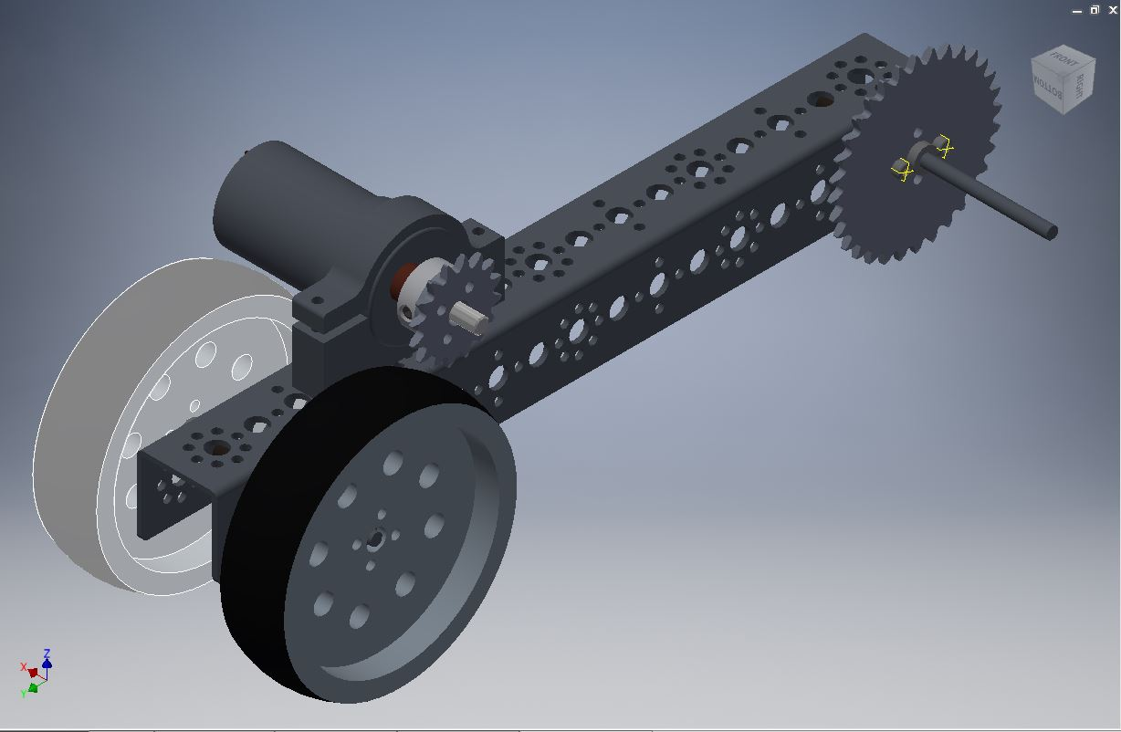
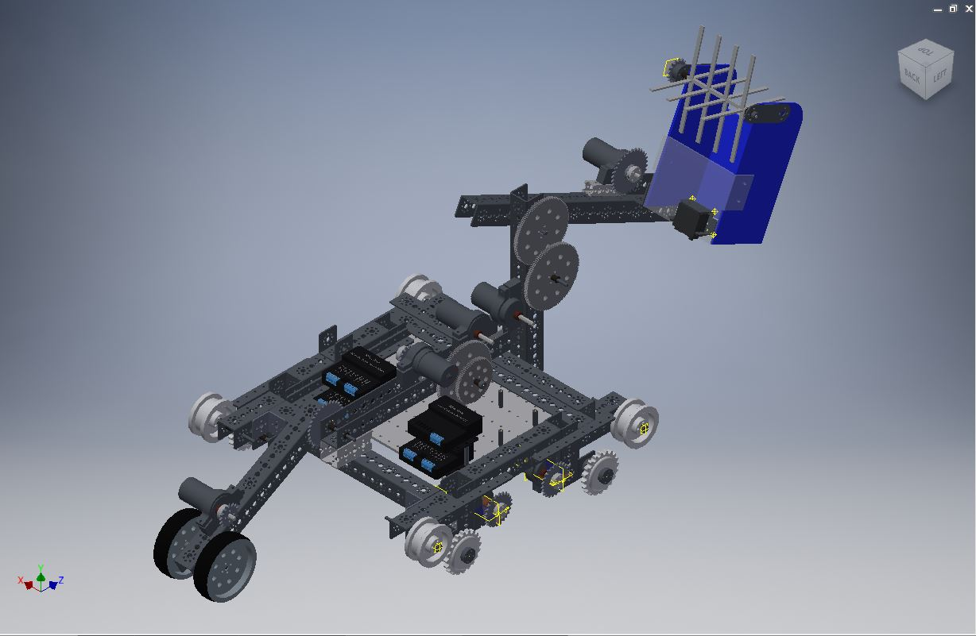
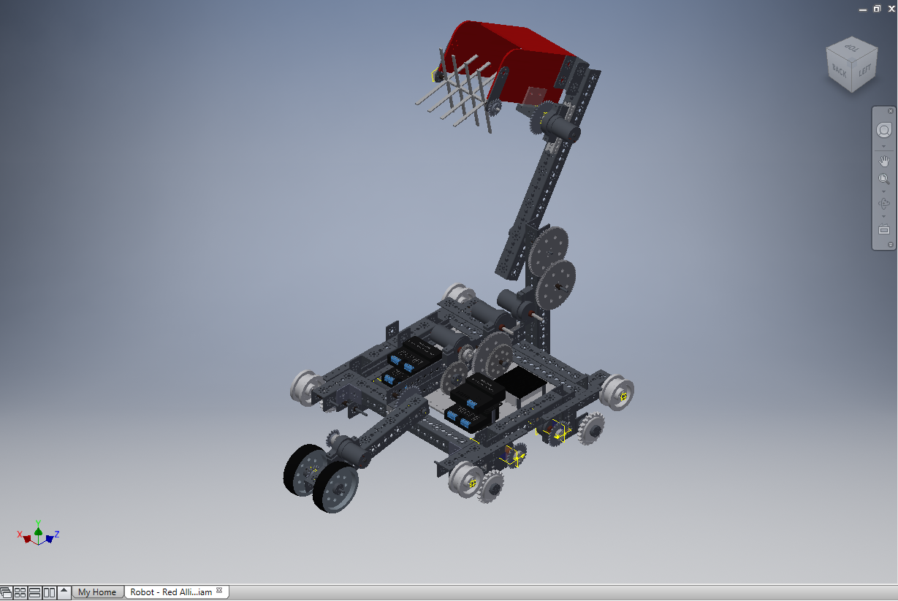
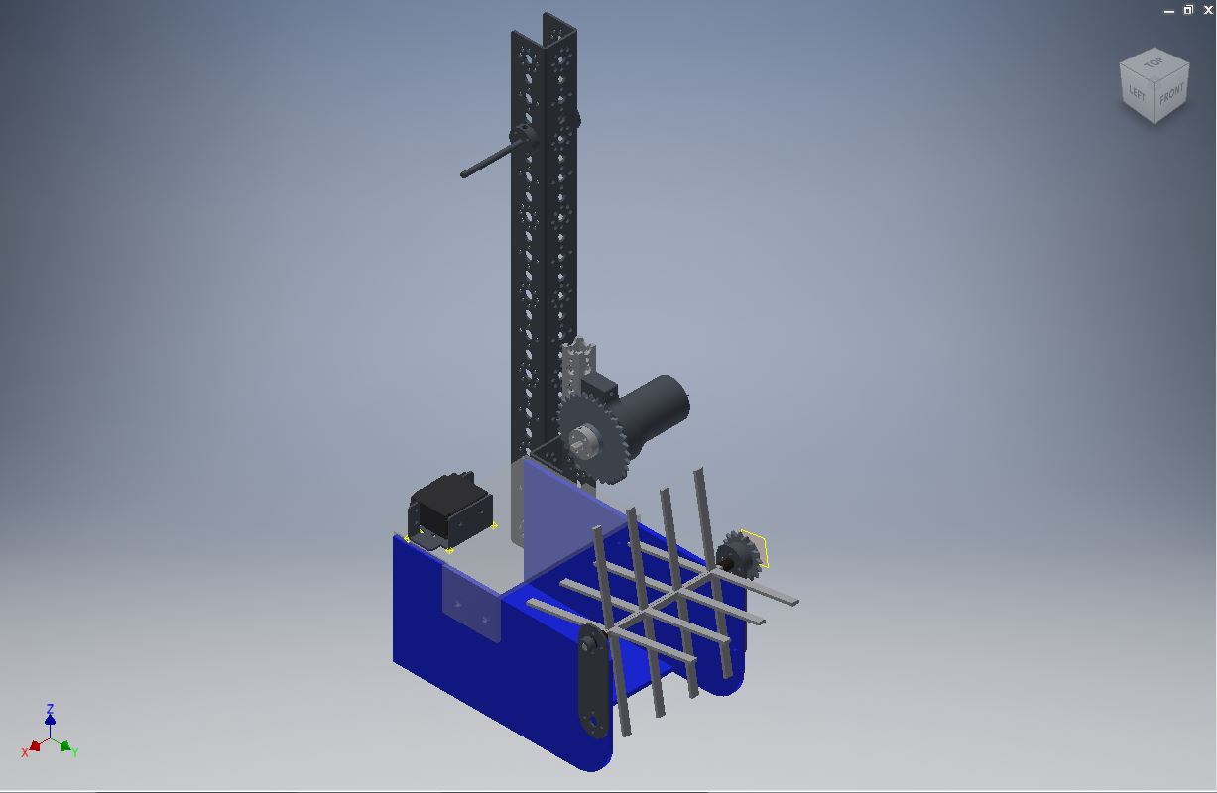
Future Designs and Plans

The Two-Face Protocol

When we started this season out, we designed our robot in a particular way that made it hard to score if we are on the Blue alliance. This is because our chassis and arm placement are set up on the left side of the robot, which gives us the ability to score efficiently on the right side of the ramp. This was a good strategy, unless we are on the blue alliance, for which we can only climb the left side of the ramp. Currently, we still have this design, which we can still use to score in the bottom buckets. Our solution was to design a mirror robot. We took our current design, made a few measurement changes, and then modeled it in reverse. If we have the opportunity to carry out this idea, our robot would have two different arms, and two different wheelie bars.

Depending on which alliance we are on for any given mach, we would connect that corresponding arm and wheelie bar assembly.

